Smack Dab in the Middle of Maybe
Book and Reading Group Discussion Questions for Adults
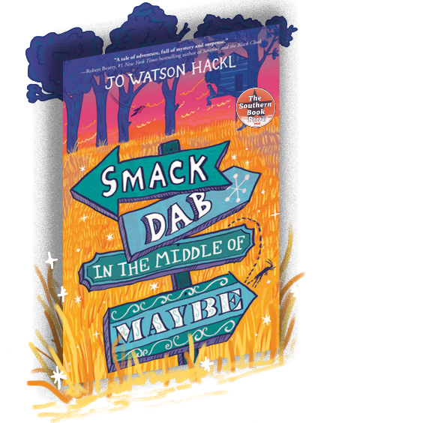
Smack Dab in the Middle of Maybe takes you on a journey with 12-year-old Cricket who runs away to live in an overgrown ghost town. Her goal: to try to solve a clue trail left by a reclusive artist with a logic all his own. The clue trail was inspired by the artwork of Southern artist Walter Inglis Anderson, who painted a secret room and used the light from the windows to make the paintings seem to come alive. Smack Dab was awarded the Southern Book Prize, the Mississippi Library Association Author Award, and is an Amazon Teacher’s Pick and a Publishers Weekly bestseller.

The story is set in a fictionalized version of the real-life ghost town of Electric Mills, Mississippi, where I grew up. To write the book, I drew upon my childhood experiences of exploring the half-wild and history-haunted woods of the ghost town and my years of studying poetry, art, outdoor survival, and Southern folk traditions. I hope that you enjoy reading it every bit as much as I enjoyed writing it.

We’ve included below some topics and questions for discussion. To take your book club experience to the next level, you can also find links to activities and a book club menu and chapter-paired playlist

Wishing you much fun with your reading companions!

Jo Watson Hackl

P.S. I love to see social media posts of individual readers and book clubs enjoying Smack Dab! Just tag @Jo Hackl (twitter and IG) and @Jo Watson Hackl, Author (FB) and I’ll share it.

Topics and Questions for Discussion

- When Smack Dab’s main character, Cricket, rescues a real cricket from Thelma’s Cash ‘n’ Carry Grocery store, it starts a chain of events that changes her life and propels the story forward. Have you ever rescued an animal with unexpected results? If so, describe what happened.

- Cricket reacts to the art of the fictional artist, Bob, on an emotional as well as intellectual level. Is there an artist (musical, visual, literary, or otherwise) whose work changed the way you look at things in the world? If so, who and how?

- To which character did you most relate in the book? Why?

- If this book were made into a movie, who would you cast as each of the characters?

- If you had to select a new title for the book, what would it be and why?

- Are there any questions or scenes from the book that still linger in your mind? What are they? Why do you think that they resonated with you?

- If you had to pick a theme song for each character, what would it be and why?

- Aunt Belinda and Cricket start out in very different places. Are there any ways that Aunt Belinda and Cricket became more like each other by the end of the novel? How so?

- What do you think happens to each of the characters after the book ends?

- As an author, I tried to make the ghost town setting act as a character in the book. Do you think that I succeeded? Why or why not? What would you change?

- The land always affects those who live on it. How would you describe each of the character’s relationship with the place they lived? How did those relationships evolve throughout the book?

- Cricket missed out on a lot of days at school, but she was always learning. Discuss how and what she learned throughout the novel, even while on her own.

- Is there anything that you’d like to say to any of the characters? What is it?

- Did you agree with Cricket’s decisions? Why or why not?

- Imagine Cricket 10 years later as a young woman. What types of things do you think she would value as an adult? Why? How do you think that her experiences in the ghost town would have changed her?

- Are there any of the things that Cricket learned in the ghost town that you’d like to try out in real life? What are they?

- What do you think is the central theme of Smack Dab? Do you believe that it delivers the same message or different messages to adult and young readers?

- I included a number of symbolic elements in Smack Dab. Are there any that especially resonated with you? Are there any that rubbed you the wrong way? Why?

- Was the reunion between Cricket and her mother what you expected? As a reader, did you feel satisfied with the ending? Why or why not?

- Imagine that Cricket's mother never left. How would Cricket's life have been different? Is there an event in your life that caused your life to drastically change course?
Enhance your Book Club Experience

- Bring Smack Dab’s setting to life with some good, old-fashioned cooking featuring Mississippi recipes and Mississippi ingredients. You can find a book club menu featuring book-inspired dishes (and a video with recipes) here

- You can find a link to the real-life Southern places that inspired parts of the book here

- You can find a playlist featuring Mississippi artists with chapter pairings here

Other Group Activities:

- Go on a group outing to a local park and try out some of the nature activities such as the “Cricket Challenges,” “Create Your Own Woods Time,” “Bloom Bingo,” or “Scavenger Hunt” through the links on the “For Readers” section of the website.

- Write a short story or poem based on one of your own childhood experiences. If you feel comfortable, share your story with the group.

- Pick a random page of Smack Dab and create a blackout poem. As you read the page, lightly circle words that speak to you or relate to a theme that you’d like to convey. Than use a heavy marker to black out all but the words that you’d like to use to create your poem.

- The town of Electric City had its own coin, the doogaloo, with a symbol of the electric power of which it was so proud. If Electric City had a slogan, it would be “Work hard, help your neighbors, and let your talents shine bright.” If your reading group doesn’t yet have a slogan or a symbol, you can create one in the space below:

Slogan: Symbol:

If you have any questions about Smack Dab, you can reach out to me on the “Contact Me” tab of my website. I look forward to hearing from you!

